SIMATS ENGINEERING
ASSESSMENT TOOL 1

COURSE NAME: COMPUTER ARCHITECTURE COURSE CODE: CSA12

COURSE OUTCOME COVERED
CO1: Components of a computer system, including CPU, memory, and I/O. Basic
Operational Concepts: Instruction execution cycle, instruction fetch and decode.Bus
Structures: Single-bus, multi-bus, and hierarchical buses.Factors of Performance:
CPU execution time, CPI, clock cycles, and benchmarking.8085 and 8086
Architectures: Overview, instruction sets, and addressing modes. Modern
Architectures: ARM Cortex, Intel Core, and AMD Ryzen.Instruction Sets, Formats, and
Addressing Modes. Number Systems: Binary, hexadecimal, and their applications in
computer systems. (BL4)
Assessment Tool Weightage: 40%

QUESTIONS:5 Total Marks:25

ANNEXURE A
APPLICATION BASED QUESTIONS

Code of Conduct:
I (Name / Reg No) certify that this submission is my original
work and that I have adhered to the guidelines specified for this assessment.
I understand that any violation of academic integrity rules will result in disciplinary
action.
Signature of the student:
ANNEXURE A

1. A smart city surveillance system processes continuous video feeds from multiple cameras, where
large volumes of data are transferred between I/O devices, memory, and CPU. During peak hours,
the system experiences lag and delayed response in threat detection. Analyze how the interaction
between CPU, memory, and I/O contributes to this issue, and explain how different bus structures
(single-bus vs multi-bus) and improvements in instruction execution cycle can enhance system
performance.
2. A real-time stock trading application running on a processor executes millions of instructions per
second, but users report delays in transaction processing during high load. The system has a high
CPI due to frequent memory access and branch instructions. Examine how the fetch–decode–
execute cycle impacts execution time in this scenario, and propose methods to reduce CPI and
improve overall CPU performance using suitable architectural enhancements.
3. An embedded system based on an 8085 microprocessor is used in an industrial temperature control
unit, where sensors provide input and actuators respond accordingly. However, incorrect
temperature readings are occasionally processed due to improper use of addressing modes in the
program. Discuss how different addressing modes influence data access, identify possible causes
of such errors, and suggest how the instruction set of 8085 can be effectively used to ensure
accurate and reliable operation.
4. A computing system uses an 8086 microprocessor with segmented memory for executing multiple
programs simultaneously, but it encounters issues like incorrect data access and stack overflow
errors. Evaluate how segmentation (code, data, and stack segments) works in 8086, analyze how
improper segment handling can lead to such problems, and explain how instruction execution and
addressing modes must be managed to ensure correct program execution.
5. A data communication system represents packet information in hexadecimal format for ease of
debugging and transmission, but a software engineer mistakenly interprets values, leading to
incorrect data processing. Analyze the importance of number system conversions between
hexadecimal and binary in such systems, explain how errors in conversion can affect instruction
execution, and discuss how efficient CPU design and benchmarking can help detect and minimize
such issues in real-time systems.
MARKS ALLOCATION

Criteria

Understanding
of Problem
Context (20%)

Application of
Concepts
(20%)

Problem-Solving
Approach (20%)

Accuracy of
Solution
(20%)

Clarity (20%)

Q1
Q2
Q3
Q4
Q5

KAVIYA.K
1925212077
BE ECE

1.A smart city surveillance system processes continuous video feeds from multiple cameras, where
large volumes of data are transferred between I/O devices, memory, and CPU. During peak hours,
the system experiences lag and delayed response in threat detection. Analyze how the interaction
between CPU, memory, and I/O contributes to this issue, and explain how different bus structures
(single-bus vs multi-bus) and improvements in instruction execution cycle can enhance system
performance.
Q1. A Smart City Surveillance System Processes Continuous Video Feeds
Introduction
A smart city surveillance system uses many CCTV cameras to monitor roads, buildings, traffic, and public places. The cameras continuously send video data to the computer system. The CPU processes the video, memory stores the data, and I/O devices transfer the data. During peak hours, a large amount of video data causes the system to become slow. This results in delays in detecting threats and responding to emergencies.
Components of the Computer System
1. CPU (Central Processing Unit)
- CPU is called the brain of the computer.
- It executes instructions and processes video data.
- It performs calculations and makes decisions.
- It controls all operations in the surveillance system.
2. Memory
- Memory stores instructions and video data.
- RAM temporarily stores the video being processed.
- Cache memory stores frequently used data to increase speed.
- Faster memory improves CPU performance.
3. Input/Output (I/O) Devices
- Cameras act as input devices.
- Monitor, alarm, and storage devices act as output devices.
- I/O devices communicate with the CPU through buses.
Interaction Between CPU, Memory and I/O
- Cameras capture video.
- Video data is transferred to memory.
- CPU fetches data from memory.
- CPU decodes and processes the video.
- The result is displayed or stored.
All these operations require continuous communication through the system bus.
Reasons for Lag
- Many cameras generate huge amounts of data.
- CPU cannot process all data immediately.
- Memory becomes busy storing video frames.
- A single bus becomes congested because all devices use the same communication path.
- CPU spends more time waiting for data.
Single Bus Architecture
Advantages
- Simple design.
- Low cost.
- Easy to maintain.
Disadvantages
- Only one data transfer at a time.
- Heavy traffic during peak hours.
- CPU, memory, and I/O devices compete for the same bus.
- Performance decreases.
Multi-Bus Architecture
Advantages
- Uses separate buses for CPU, memory, and I/O.
- Multiple data transfers occur simultaneously.
- Reduces waiting time.
- Improves system speed.
- Suitable for real-time surveillance systems.
Disadvantages
- Higher cost.
- More complex design.
Instruction Execution Cycle
Every instruction follows four steps:
- Fetch – CPU fetches instruction from memory.
- Decode – CPU understands the instruction.
- Execute – CPU performs the operation.
- Store – Result is stored back in memory.
Methods to Improve Performance
- Use cache memory.
- Use pipelining.
- Increase CPU clock speed.
- Use multi-core processors.
- Use faster RAM.
- Use multi-bus architecture.
Conclusion
A smart city surveillance system requires fast communication between CPU, memory, and I/O devices. Using a multi-bus architecture, cache memory, pipelining, and faster processors reduces delays and improves overall system performance.

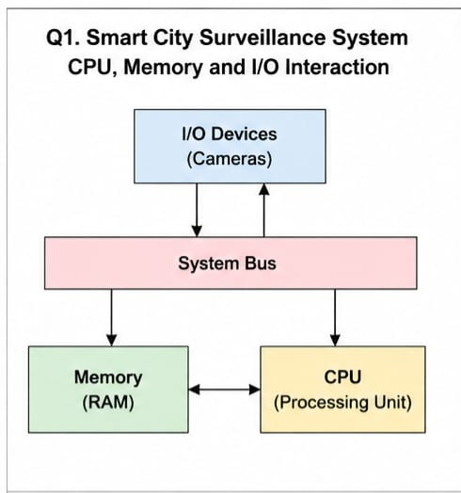

2.A real-time stock trading application running on a processor executes millions of instructions per
second, but users report delays in transaction processing during high load. The system has a high
CPI due to frequent memory access and branch instructions. Examine how the fetch–decode–
execute cycle impacts execution time in this scenario, and propose methods to reduce CPI and
improve overall CPU performance using suitable architectural enhancements.

Q2. Real-Time Stock Trading Application
Introduction
A stock trading application processes millions of transactions every second. During high traffic, users experience delays because the CPU spends more time executing instructions. This happens due to high Cycles Per Instruction (CPI).
Instruction Execution Cycle
The CPU executes every instruction in four stages:
1. Fetch
- CPU fetches the instruction from memory.
2. Decode
- CPU identifies the operation to perform.
3. Execute
- CPU performs arithmetic or logical operations.
4. Store
- The result is stored in memory.
If this cycle becomes slow, transaction processing also becomes slow.
Reasons for High CPI
- Frequent memory access.
- Cache misses.
- Large number of branch instructions.
- CPU waiting for memory.
- Slow system bus.
Impact of High CPI
- Increased CPU execution time.
- Slow transaction processing.
- Poor user experience.
- Delayed buying and selling of shares.
- Reduced system performance.
Methods to Reduce CPI
1. Cache Memory
Stores frequently used data closer to CPU.
2. Pipelining
Allows multiple instructions to execute simultaneously.
3. Branch Prediction
Predicts branch instructions and reduces waiting time.
4. Faster RAM
Reduces memory access delay.
5. Multi-Core Processor
Allows multiple transactions to be processed at the same time.
Architectural Enhancements
- Superscalar processors.
- Larger cache.
- High-speed buses.
- Better instruction scheduling.
- Parallel processing.
Conclusion
Reducing CPI using cache memory, pipelining, branch prediction, and multi-core processors improves CPU performance and allows faster stock trading.

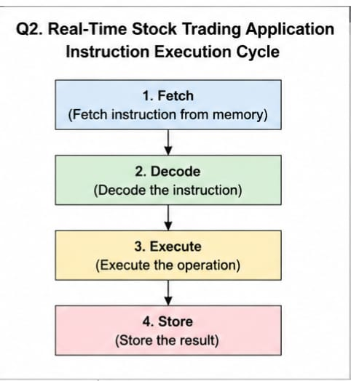

3.A real-time stock trading application running on a processor executes millions of instructions per
second, but users report delays in transaction processing during high load. The system has a high
CPI due to frequent memory access and branch instructions. Examine how the fetch–decode–
execute cycle impacts execution time in this scenario, and propose methods to reduce CPI and
improve overall CPU performance using suitable architectural enhancements.

Q3. 8085 Temperature Control System
Introduction
An industrial temperature control system uses the 8085 microprocessor to read temperature from sensors and control actuators. If incorrect addressing modes are used, the processor may access the wrong data, resulting in incorrect temperature readings and unreliable operation.
8085 Addressing Modes
1. Immediate Addressing Mode
- Data is given directly in the instruction.
- Example: MVI A,25H
2. Register Addressing Mode
- Data is stored in CPU registers.
- Example: MOV A,B
3. Direct Addressing Mode
- Memory address is specified directly.
- Example: LDA 2500H
4. Register Indirect Addressing Mode
- Memory address is stored in register pair.
- Example: MOV A,M
5. Implied Addressing Mode
- Operand is implied in the instruction.
- Example: CMA
Effect of Addressing Modes
- Correct addressing accesses the correct sensor data.
- Wrong addressing reads incorrect memory locations.
- This causes wrong temperature calculations.
Possible Causes of Errors
- Incorrect memory address.
- Wrong register selection.
- Programming mistakes.
- Faulty sensor input.
- Incorrect instruction usage.
8085 Instructions Used
- MOV – Transfer data.
- MVI – Load immediate data.
- LDA – Load accumulator.
- STA – Store accumulator.
- ADD – Add data.
- SUB – Subtract data.
- CMP – Compare values.
Methods to Ensure Accuracy
- Select the correct addressing mode.
- Use proper memory addresses.
- Validate sensor data.
- Test the program thoroughly.
- Debug the program before implementation.
Advantages
- Accurate temperature readings.
- Reliable system operation.
- Reduced programming errors.
- Better industrial safety.
Conclusion
Proper use of 8085 addressing modes and instructions ensures accurate data access, reliable temperature control, and efficient system performance.

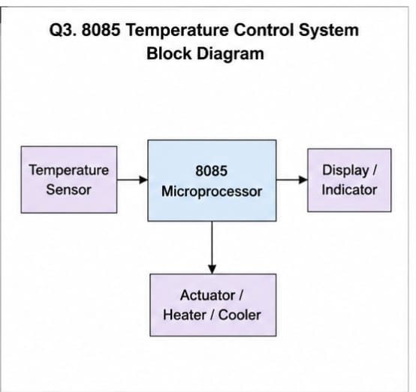

4.A computing system uses an 8086 microprocessor with segmented memory for executing multiple
programs simultaneously, but it encounters issues like incorrect data access and stack overflow
errors. Evaluate how segmentation (code, data, and stack segments) works in 8086, analyze how
improper segment handling can lead to such problems, and explain how instruction execution and
addressing modes must be managed to ensure correct program execution.
Q4. 8086 Segmentation
Introduction
The 8086 microprocessor uses segmented memory to access up to 1 MB of memory. Memory is divided into different segments to organize programs efficiently. Improper handling of segments can cause incorrect data access and stack overflow errors.
Segments in 8086
1. Code Segment (CS)
- Stores program instructions.
2. Data Segment (DS)
- Stores variables and data.
3. Stack Segment (SS)
- Stores function calls, local variables, and return addresses.
4. Extra Segment (ES)
- Stores additional data during string operations.
Working of Segmentation
The physical address is calculated using:
Physical Address = Segment × 16 + Offset
Example:
Segment = 2000H
Offset = 1500H
Physical Address = 21500H
Problems Due to Improper Segmentation
- Wrong segment register causes incorrect data access.
- Stack overflow occurs when stack memory exceeds its limit.
- Wrong memory locations are accessed.
- Program execution becomes incorrect.
Instruction Execution in 8086
- Fetch instruction.
- Decode instruction.
- Execute instruction.
- Store result.
Correct segment registers must be used during every step.
Addressing Modes Used
- Immediate.
- Register.
- Direct.
- Register Indirect.
- Based.
- Indexed.
- Based Indexed.
Methods to Avoid Errors
- Initialize segment registers correctly.
- Allocate enough stack memory.
- Use correct addressing modes.
- Check memory boundaries.
- Test the program before execution.
Advantages
- Efficient memory management.
- Supports larger programs.
- Better organization of data.
- Faster program execution.
Conclusion
Proper segmentation and addressing modes ensure correct memory access, prevent stack overflow, and improve the reliability of 8086-based systems.

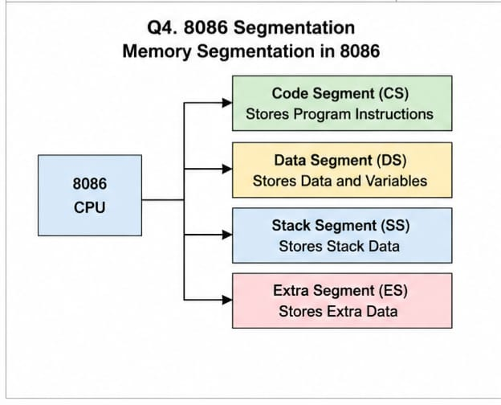
5.A data communication system represents packet information in hexadecimal format for ease of
debugging and transmission, but a software engineer mistakenly interprets values, leading to
incorrect data processing. Analyze the importance of number system conversions between
hexadecimal and binary in such systems, explain how errors in conversion can affect instruction
execution, and discuss how efficient CPU design and benchmarking can help detect and minimize
such issues in real-time systems.
Q5. Number System Conversion
Introduction
Computers use the binary number system, while programmers often use the hexadecimal number system because it is shorter and easier to read. Correct conversion between hexadecimal and binary is essential for accurate instruction execution and data processing.
Binary Number System
- Uses only 0 and 1.
- Understood directly by the CPU.
- Used for all internal operations.
Hexadecimal Number System
- Uses digits 0–9 and letters A–F.
- One hexadecimal digit represents 4 binary bits.
- Commonly used in memory addresses and debugging.
Importance of Conversion
- Converts user-friendly hexadecimal into binary.
- Helps in memory addressing.
- Used in instruction execution.
- Makes debugging easier.
- Improves communication between hardware and software.
Effects of Incorrect Conversion
- Wrong instruction execution.
- Incorrect memory addresses.
- Data corruption.
- Communication errors.
- Program failure.
Role of Efficient CPU Design
- Fast ALU performs binary operations quickly.
- Cache memory speeds up data access.
- Faster clock speed improves execution.
- Better architecture reduces delays.
Role of Benchmarking
Benchmarking measures:
- CPU execution time.
- Clock cycles.
- CPI (Cycles Per Instruction).
- Overall processor performance.
It helps identify bottlenecks and improve system efficiency.
Advantages
- Accurate data processing.
- Faster execution.
- Easy debugging.
- Reliable communication.
- Better overall system performance.
Conclusion
Correct hexadecimal-to-binary conversion is essential for proper instruction execution and memory access. Efficient CPU design, cache memory, and benchmarking improve performance and reduce errors in real-time computer systems.

